**What are Azure DevOps Reporting capabilities?**

* Watch this 18mins [video](https://channel9.msdn.com/Events/connect/2017/T251) on ADO reporting capabilities.
* Reporting is one of the most powerful features of ADO.
* [Analytics](https://docs.microsoft.com/en-us/azure/devops/report/powerbi/what-is-analytics?view=azure-devops&viewFallbackFrom=vsts) is the reporting platform for ADO.

Key Analytics features:

1. **Dashboard Analytics widgets** *(Within ADO)*
2. **In-context reports** *(Within ADO)*
3. **Roll-up columns** *(Within ADO)*
4. **Analytics Views** *(with Power BI)*

**Note**: In 2017, Analytics was launched as a market extension, but it is now a built-in functionality, offered at no extra cost.

# [**Dashboard Analytics widgets**](https://docs.microsoft.com/en-us/azure/devops/report/powerbi/what-is-analytics?view=azure-devops#dashboard-widgets)

Analytics provides several [advanced widgets](https://docs.microsoft.com/en-us/azure/devops/report/dashboards/analytics-widgets), to provide instant insights, for example :

|  |  |  |  |
| --- | --- | --- | --- |
| [**Burndown**](https://docs.microsoft.com/en-us/azure/devops/report/dashboards/analytics-widgets?view=azure-devops#burndown) | [**Sprint Burndown**](https://docs.microsoft.com/en-us/azure/devops/report/dashboards/analytics-widgets?view=azure-devops#sprint-burndown-widget) | [**Cycle Time**](https://docs.microsoft.com/en-us/azure/devops/report/dashboards/analytics-widgets?view=azure-devops#cycle-time) | [**Velocity**](https://docs.microsoft.com/en-us/azure/devops/report/dashboards/analytics-widgets?view=azure-devops#velocity) |
| [**Burnup**](https://docs.microsoft.com/en-us/azure/devops/report/dashboards/analytics-widgets?view=azure-devops#burnup) | [**CFD**](https://docs.microsoft.com/en-us/azure/devops/report/dashboards/analytics-widgets?view=azure-devops#cumulative-flow-diagram-cfd) | [**Lead Time**](https://docs.microsoft.com/en-us/azure/devops/report/dashboards/analytics-widgets?view=azure-devops#lead-time) | [**Test Results Trend**](https://docs.microsoft.com/en-us/azure/devops/report/dashboards/analytics-widgets?view=azure-devops#test-results-trend-advanced) |

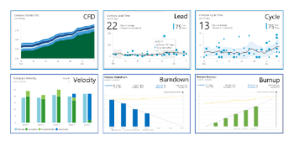

# [**In-context reports**](https://docs.microsoft.com/en-us/azure/devops/report/powerbi/what-is-analytics?view=azure-devops#in-context-reports-and-roll-up-columns)

**In-context reports** are system-generated charts that support specific services. With [Sprint 155 Update](https://docs.microsoft.com/en-us/azure/devops/release-notes/2019/boards/sprint-155-update), ADO has made it easier for teams to track these important metrics with minimal effort right inside Azure Boards. Introduced three new interactive reports: **Sprint Burndown** under the Sprints hub, and **Cumulative Flow Diagram CFD)** and **Velocity** under the Backlogs and Boards hubs under the Analytics tab. The new reports are fully interactive and allow teams to adjust them for their needs.

|  |  |  |
| --- | --- | --- |
| [**Team velocity**](https://docs.microsoft.com/en-us/azure/devops/report/dashboards/team-velocity?view=azure-devops) | [**Cumulative flow**](https://docs.microsoft.com/en-us/azure/devops/report/dashboards/cumulative-flow?view=azure-devops) | [**Sprint burndown**](https://docs.microsoft.com/en-us/azure/devops/report/dashboards/configure-sprint-burndown?view=azure-devops) |

Refer: <https://devblogs.microsoft.com/devops/boards-analytics-reports/> , [Video](https://www.youtube.com/watch?v=fS5Q3Y2AZZQ&feature=youtu.be&t=81)

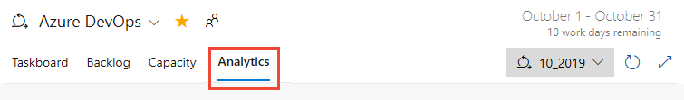

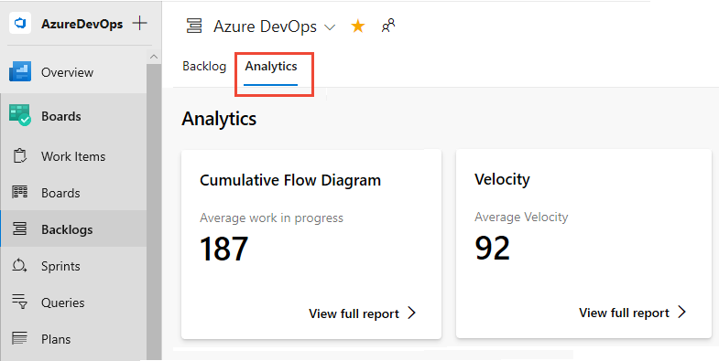

# **[Rollup Columns](https://devblogs.microsoft.com/devops/track-the-progress-of-work-using-rollup-columns/)**

Rollup is based on the [Analytics service](https://aka.ms/BacklogRollup). Rollup is an aggregation displayed on a parent item (like Epic, Feature or even User story) calculated based on [parent child relationships](https://docs.microsoft.com/en-us/azure/devops/boards/queries/link-work-items-support-traceability?toc=/azure/devops/boards/toc.json&bc=/azure/devops/boards/breadcrumb/toc.json%20toc.json&view=azure-devops&tabs=new-web-form#parent-child-work-item-links). For example, at the Feature backlog you can track progress of each of the Features based on the sum of Story Points for the **completed** linked User Stories

# **[Analytics Views (Power BI)](https://docs.microsoft.com/en-us/azure/devops/report/powerbi/what-are-analytics-views?view=azure-devops&viewFallbackFrom=vsts)**

Analytics reporting platform aka Analytics Service has become the pathway to Power BI to provide deeper insights into the data. Power BI is a powerful platform to explore, visualise and share the data.

“**Analytics Views**” feature is an easy-to-use solution for seamlessly integrating Power BI with ADO Analytics. You don’t have to know how to write OData queries anymore!  
Similar to a work items query, an Analytics View specifies filters that scope the result of work items data and the columns. Additionally, views allow you to report on past revisions of work items and easily create trend reports.

ADO provides a set of [Default Analytics views](https://docs.microsoft.com/en-us/vsts/report/analytics/analytics-default-views) as below that work well for customers with smaller accounts and basic scenarios. Larger accounts might need to scope down the data they are pulling into Power BI so you can create your own Analytics views.

Analytics views let you do just that. Scope your data and history to exactly what you want to report on in Power BI.

Note:  Analytics views you create in the Analytics hub in ADO are immediately available to select from the [Power BI Data Connector](https://docs.microsoft.com/en-us/vsts/report/powerbi/data-connector-connect?view=vsts).

|  |  |  |  |
| --- | --- | --- | --- |
| **Bugs**-All history by month | **Stories**-All history by month | **Tasks**-All history by month | **Work Items**-All history by month |
| **Bugs**-Last 26 weeks | **Stories**-Last 26 weeks | **Tasks**-Last 26 weeks | **Work Items**-Last 26 weeks |
| **Bugs**-Last 30 days | **Stories**-Last 30 days | **Tasks**-Last 30 days | **Work Items**-Last 30 days |
| **Bugs**-Today | **Stories**-Today | **Tasks**-Today | **Work Items**-Today |

(Default Analytics View)

For developers wanting to create more powerful reports, tools or widgets, data can be pulled in Power BI using OData feed. Odata provide access to all the data so can just about do anything. OData is open standard protocol for accessing the data.

# [**Dashboards, Charts & Widgets**](https://docs.microsoft.com/en-us/azure/devops/report/dashboards/overview?view=azure-devops) **in ADO**

Besides Analytics features, you can also gain visibility into your team's progress by adding one or more widgets or charts to your dashboard.

## Dashboards

**Dashboards** are customizable interactive signboards that provide real-time information. Dashboards are associated with a team or a project and display configurable charts and widgets.

Dashboard Videos to watch:

* [Dashboards in VSTS](https://www.youtube.com/watch?v=oqor4duK5aY) 2015 Video, 8mins
* [Dashboard capabilities](https://www.youtube.com/watch?v=KqmxHm-Tc38) 2015 Video, 10mins
* [Analyse and report your work in ADO](https://www.youtube.com/watch?v=VXdgjRdtBQI) 2018 Video, 23mins
* EPC Demo [Video](https://web.microsoftstream.com/video/7a3a2a84-d662-498d-a3f9-36084996dcdb) 2020, 5mins
* Query Pro widget setup: [demo video 1](https://web.microsoftstream.com/video/59cf7f99-867e-42d2-aee7-17d632bb7e01), [demo video 2](https://web.microsoftstream.com/video/61df0d43-0e4a-483b-a321-2b5e5bf81ed7) 2020, 5mins

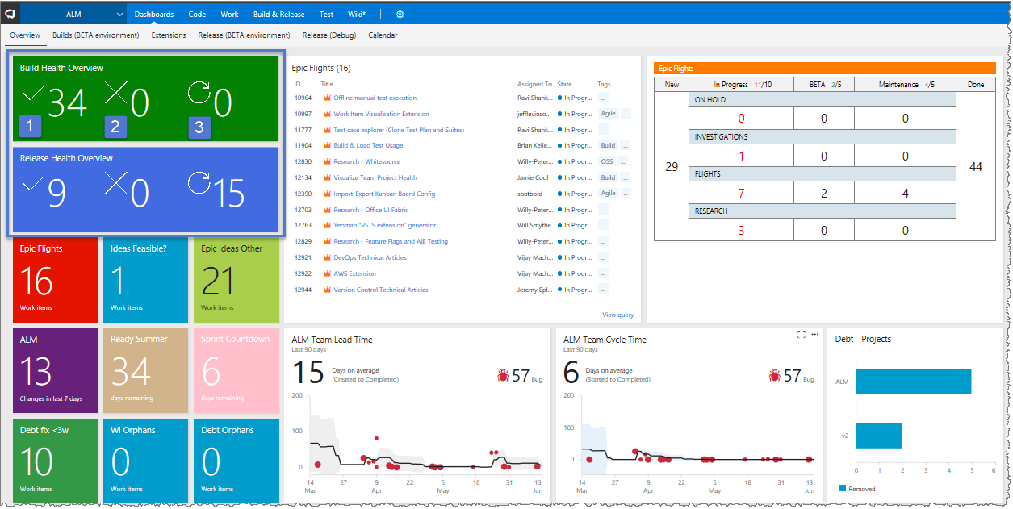

* You can make your Visual Studio Team Services dashboard part of your conversation in Microsoft Teams. To learn more, click [here](https://devblogs.microsoft.com/devops/make-your-visual-studio-team-services-dashboard-part-of-your-conversation-in-microsoft-teams/).
* The “**Copy to Dashboard**” feature helps you replicating dashboards widgets in different ADO dashboard. In your ADO team project account, you may have several dashboards. Each dashboard is a collection of Widgets. Some of the widgets need different configuration to populate data. You may want them in the different dashboard as well. Here, instead of creating the same dashboard widget with the same set of configuration, you can just copy it from the existing dashboard. It will help in saving a lot of time and effort.

## Charts

With flat-list queries, you can create various charts to monitor status, progress, and trends. To get started, you can open a shared query and create a chart based on your tracking interests. Chart types include status—**pie**, **bar**, **column**, **stacked bar**, and **pivot**—and **trend**—stacked area, line, and area—charts.

## Widgets

You add widgets to a dashboard to display a chart, information, or set of links. Most widgets are configurable. For a description of each supported widget for your platform and version, see the [Widget catalog](https://docs.microsoft.com/en-us/azure/devops/report/dashboards/widget-catalog?view=azure-devops). Here are all the Azure Board widgets supported in BP-IT Org.

Also, you can create a [dashboard widget](https://www.visualstudio.com/docs/integrate/extensions/develop/add-dashboard-widget) using the REST API service.

|  |  |  |
| --- | --- | --- |
| * [Assigned to me](https://docs.microsoft.com/en-us/azure/devops/report/dashboards/widget-catalog?view=azure-devops#assigned-to-me-widget) | * [Lead time](https://docs.microsoft.com/en-us/azure/devops/report/dashboards/widget-catalog?view=azure-devops#lead-time-widget) (Analytics) | * [Sprint burndown - Legacy](https://docs.microsoft.com/en-us/azure/devops/report/dashboards/widget-catalog?view=azure-devops#sprint-burndown-widget) |
| * [Backlog Item Hierarchy](https://marketplace.visualstudio.com/items?itemName=cellenza.WI-Hierarchy-Widget) (Marketplace) | * [Markdown](https://docs.microsoft.com/en-us/azure/devops/report/dashboards/widget-catalog?view=azure-devops#markdown) | * [Sprint capacity](https://docs.microsoft.com/en-us/azure/devops/report/dashboards/widget-catalog?view=azure-devops#sprint-capacity-widget) |
| * [Burndown chart](https://docs.microsoft.com/en-us/azure/devops/report/dashboards/widget-catalog?view=azure-devops#burndown-analytics-widget) (Analytics) | * [New Work item](https://docs.microsoft.com/en-us/azure/devops/report/dashboards/widget-catalog?view=azure-devops#new-work-item-widget) | * [Sprint Goal](https://marketplace.visualstudio.com/items?itemName=keesschollaart.sprint-goal) (Marketplace) |
| * [Burnup chart](https://docs.microsoft.com/en-us/azure/devops/report/dashboards/widget-catalog?view=azure-devops#burnup-analytics-widget) (Analytics) | * [Other Links](https://docs.microsoft.com/en-us/azure/devops/report/dashboards/widget-catalog?view=azure-devops#other-links) | * [Sprint overview](https://docs.microsoft.com/en-us/azure/devops/report/dashboards/widget-catalog?view=azure-devops#sprint-overview-widget) |
| * [Chart for test plans](https://docs.microsoft.com/en-us/azure/devops/report/dashboards/widget-catalog?view=azure-devops#chart-for-test-plans) | * [Personas](https://marketplace.visualstudio.com/items?itemName=agile-extensions.personas) (Marketplace) | * [Team Members](https://docs.microsoft.com/en-us/azure/devops/report/dashboards/widget-catalog?view=azure-devops#team-members) |
| * [Chart for work items](https://docs.microsoft.com/en-us/azure/devops/report/dashboards/widget-catalog?view=azure-devops#chart-wit-widget) | * [Project Teams](https://marketplace.visualstudio.com/items?itemName=davesmits.VSTSTeams) (Marketplace) | * [Velocity](https://docs.microsoft.com/en-us/azure/devops/report/dashboards/widget-catalog?view=azure-devops#velocity-widget) (Analytics) |
| * [Countdown](https://marketplace.visualstudio.com/items?itemName=ALM-DevOpsRangers.CountdownWidget) (Marketplace) | * [Query results](https://docs.microsoft.com/en-us/azure/devops/report/dashboards/widget-catalog?view=azure-devops#query-results-widget) | * [Visual Studio Shortcuts](https://docs.microsoft.com/en-us/azure/devops/report/dashboards/widget-catalog?view=azure-devops#visual-studio-shortcuts) |
| * [Countdown Sprint](https://marketplace.visualstudio.com/items?itemName=ALM-DevOpsRangers.CountdownWidget) (Marketplace) | * [Query tile](https://docs.microsoft.com/en-us/azure/devops/report/dashboards/widget-catalog?view=azure-devops#query-tile-widget) | * [Welcome](https://docs.microsoft.com/en-us/azure/devops/report/dashboards/widget-catalog?view=azure-devops#welcome) |
| * [Cumulative flow diagram](https://docs.microsoft.com/en-us/azure/devops/report/dashboards/widget-catalog?view=azure-devops#cfd-widget) (Analytics) | * [Query Title extended](https://marketplace.visualstudio.com/items?itemName=aurelien-sudre.querytile-extended) (Marketplace) | * [Work Item Details](https://marketplace.visualstudio.com/items?itemName=ms-devlabs.WorkItemDetails) (Marketplace) |
| * [Cycle time](https://docs.microsoft.com/en-us/azure/devops/report/dashboards/widget-catalog?view=azure-devops#cycle-time-widget) (Analytics) | * [Query Tile Pro](https://marketplace.visualstudio.com/items?itemName=mskold.mskold-Query-Tile-PRO) (Marketplace) | * [Work links](https://docs.microsoft.com/en-us/azure/devops/report/dashboards/widget-catalog?view=azure-devops#work-links-widget) |
| * [Embedded Webpage](https://docs.microsoft.com/en-us/azure/devops/report/dashboards/widget-catalog?view=azure-devops" \l "embedded-web-page) | * [Real Sprint Burndown](https://marketplace.visualstudio.com/items?itemName=tomkamphuis.vsts-extensions-myExtensions) (Marketplace) |  |
| * [Fancy Countdown](https://marketplace.visualstudio.com/items?itemName=ALM-DevOpsRangers.CountdownWidget) (Marketplace) | * [Roll-up Board](https://marketplace.visualstudio.com/items?itemName=ms-devlabs.RollUpBoard) (Marketplace) |  |
| * [iFrame dashboard](https://marketplace.visualstudio.com/items?itemName=areve.iframe-dashboard-widget) (Marketplace) | * [Sprint burndown](https://docs.microsoft.com/en-us/azure/devops/report/dashboards/widget-catalog?view=azure-devops#sprint-burndown-analytics-widget) (Analytics) |  |

Appendix.

1. [Assigned to me](https://docs.microsoft.com/en-us/azure/devops/report/dashboards/widget-catalog?view=azure-devops#assigned-to-me-widget)
2. [Backlog Item Hierarchy](https://marketplace.visualstudio.com/items?itemName=cellenza.WI-Hierarchy-Widget) (Marketplace)
3. [Burndown chart](https://docs.microsoft.com/en-us/azure/devops/report/dashboards/widget-catalog?view=azure-devops#burndown-analytics-widget) (Analytics)
4. [Burnup chart](https://docs.microsoft.com/en-us/azure/devops/report/dashboards/widget-catalog?view=azure-devops#burnup-analytics-widget) (Analytics)
5. [Chart for test plans](https://docs.microsoft.com/en-us/azure/devops/report/dashboards/widget-catalog?view=azure-devops#chart-for-test-plans)
6. [Chart for work items](https://docs.microsoft.com/en-us/azure/devops/report/dashboards/widget-catalog?view=azure-devops#chart-wit-widget)
7. [Countdown](https://marketplace.visualstudio.com/items?itemName=ALM-DevOpsRangers.CountdownWidget) (Marketplace)
8. [Countdown Sprint](https://marketplace.visualstudio.com/items?itemName=ALM-DevOpsRangers.CountdownWidget) (Marketplace)
9. [Cumulative flow diagram](https://docs.microsoft.com/en-us/azure/devops/report/dashboards/widget-catalog?view=azure-devops#cfd-widget) (Analytics)
10. [Cycle time](https://docs.microsoft.com/en-us/azure/devops/report/dashboards/widget-catalog?view=azure-devops#cycle-time-widget) (Analytics)
11. [Embedded Webpage](https://docs.microsoft.com/en-us/azure/devops/report/dashboards/widget-catalog?view=azure-devops#embedded-web-page)
12. [Fancy Countdown](https://marketplace.visualstudio.com/items?itemName=ALM-DevOpsRangers.CountdownWidget) (Marketplace)
13. [iFrame dashboard](https://marketplace.visualstudio.com/items?itemName=areve.iframe-dashboard-widget) (Marketplace)
14. [Lead time](https://docs.microsoft.com/en-us/azure/devops/report/dashboards/widget-catalog?view=azure-devops#lead-time-widget) (Analytics)
15. [Markdown](https://docs.microsoft.com/en-us/azure/devops/report/dashboards/widget-catalog?view=azure-devops#markdown)
16. [New Work item](https://docs.microsoft.com/en-us/azure/devops/report/dashboards/widget-catalog?view=azure-devops#new-work-item-widget)
17. [Other Links](https://docs.microsoft.com/en-us/azure/devops/report/dashboards/widget-catalog?view=azure-devops#other-links)
18. [Personas](https://marketplace.visualstudio.com/items?itemName=agile-extensions.personas) (Marketplace)
19. [Project Teams](https://marketplace.visualstudio.com/items?itemName=davesmits.VSTSTeams) (Marketplace)
20. [Query results](https://docs.microsoft.com/en-us/azure/devops/report/dashboards/widget-catalog?view=azure-devops#query-results-widget)
21. [Query tile](https://docs.microsoft.com/en-us/azure/devops/report/dashboards/widget-catalog?view=azure-devops#query-tile-widget)
22. [Query Title extended](https://marketplace.visualstudio.com/items?itemName=aurelien-sudre.querytile-extended) (Marketplace)
23. [Query Tile Pro](https://marketplace.visualstudio.com/items?itemName=mskold.mskold-Query-Tile-PRO) (Marketplace)
24. [Real Sprint Burndown](https://marketplace.visualstudio.com/items?itemName=tomkamphuis.vsts-extensions-myExtensions) (Marketplace)
25. [Roll-up Board](https://marketplace.visualstudio.com/items?itemName=ms-devlabs.RollUpBoard) (Marketplace)
26. [Sprint burndown](https://docs.microsoft.com/en-us/azure/devops/report/dashboards/widget-catalog?view=azure-devops#sprint-burndown-analytics-widget) (Analytics)
27. [Sprint burndown - Legacy](https://docs.microsoft.com/en-us/azure/devops/report/dashboards/widget-catalog?view=azure-devops#sprint-burndown-widget)
28. [Sprint capacity](https://docs.microsoft.com/en-us/azure/devops/report/dashboards/widget-catalog?view=azure-devops#sprint-capacity-widget)
29. [Sprint Goal](https://marketplace.visualstudio.com/items?itemName=keesschollaart.sprint-goal) (Marketplace)
30. [Sprint overview](https://docs.microsoft.com/en-us/azure/devops/report/dashboards/widget-catalog?view=azure-devops#sprint-overview-widget)
31. [Team Members](https://docs.microsoft.com/en-us/azure/devops/report/dashboards/widget-catalog?view=azure-devops#team-members)
32. [Velocity](https://docs.microsoft.com/en-us/azure/devops/report/dashboards/widget-catalog?view=azure-devops#velocity-widget) (Analytics)
33. [Visual Studio Shortcuts](https://docs.microsoft.com/en-us/azure/devops/report/dashboards/widget-catalog?view=azure-devops#visual-studio-shortcuts)
34. [Welcome](https://docs.microsoft.com/en-us/azure/devops/report/dashboards/widget-catalog?view=azure-devops#welcome)
35. [Work Item Details](https://marketplace.visualstudio.com/items?itemName=ms-devlabs.WorkItemDetails) (Marketplace)
36. [Work links](https://docs.microsoft.com/en-us/azure/devops/report/dashboards/widget-catalog?view=azure-devops#work-links-widget)